# SQL Tutorial

[](http://training.javatpoint.com/)

SQL tutorial provides basic and advanced concepts of SQL. Our SQL tutorial is designed for both beginners and professionals.

SQL (Structured Query Language) is used to perform operations on the records stored in the database, such as updating records, inserting records, deleting records, creating and modifying database tables, views, etc.

SQL is not a database system, but it is a query language.

Suppose you want to perform the queries of SQL language on the stored data in the database. You are required to install any database management system in your systems, for example, [Oracle](https://www.javatpoint.com/oracle-tutorial), [MySQL](https://www.javatpoint.com/mysql-tutorial), [MongoDB](https://www.javatpoint.com/mongodb-tutorial), [PostgreSQL](https://www.javatpoint.com/postgresql-tutorial), [SQL Server](https://www.javatpoint.com/sql-server-tutorial), [DB2](https://www.javatpoint.com/db2-tutorial), etc.

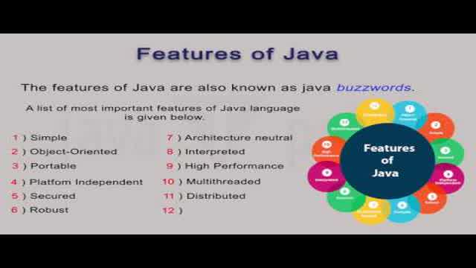

## What is SQL?

SQL is a short-form of the structured query language, and it is pronounced as S-Q-L or sometimes as See-Quell.

This database language is mainly designed for maintaining the data in relational database management systems. It is a special tool used by data professionals for handling structured data (data which is stored in the form of tables). It is also designed for stream processing in RDSMS.

You can easily create and manipulate the database, access and modify the table rows and columns, etc. This query language became the standard of ANSI in the year of 1986 and ISO in the year of 1987.

If you want to get a job in the field of data science, then it is the most important query language to learn. Big enterprises like Facebook, Instagram, and LinkedIn, use SQL for storing the data in the back-end.

## Why SQL?

Nowadays, SQL is widely used in data science and analytics. Following are the reasons which explain why it is widely used:

* The basic use of SQL for data professionals and SQL users is to insert, update, and delete the data from the relational database.